**Procedure:-**

**Step1:-**

Open AWS Services .

Inside compute service click on Lambda.

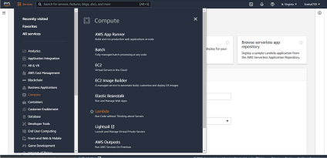**Step2:-**

After clicking on Lambda you will see the following Dashboard .

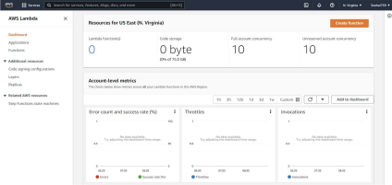**Step3:-**

Click on Create Function

You will see the following for creating a function , Give the function name select the runtime of your choice here I have selected python 3.8

And the select the execution role

**Step4:-**

Click on create

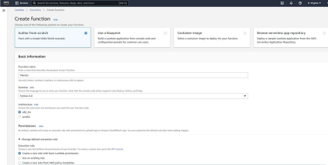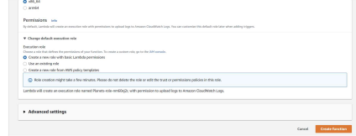**Step5:-**

Following function will be created.

You can make changes in the code source according to your convenience. 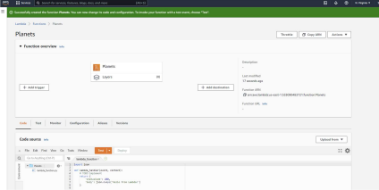

**Step6:-**

Make changes according to your will .

Click on Deploy.

Click on Test .

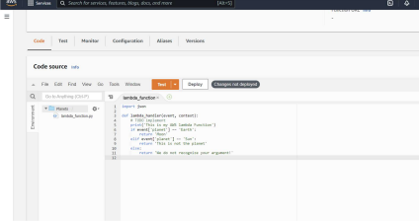**Step7:-**

Make changes based on keys and values.

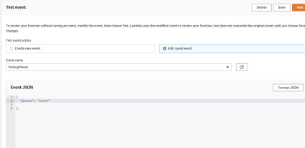**Step8:-**

If planet=Earth following output can be seen

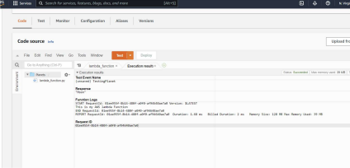

**Step9:-**

If planet=Sun

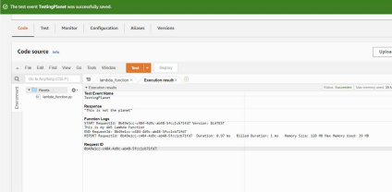

**Conclusion:-**